РАБОЧАЯ ТЕТРАДЬ №4

ЗАДАНИЕ 1
Возьмите Карту №4 и пройдите по указанному маршруту. Найдите музейный предмет. Прочтите этикетку и запишите его название по-английски.

ЗАДАНИЕ 2
Прочите нижеприведенные слова.
- brass – медь
- body – тулово
- boil – кипятить
- curved – изогнутый
- a form of – форма
- handle – ручка
- portable kettle – переносной чайник
- richly decorated – богато украшенный
- pipe – труба
- samovar – самовар
- tap – кран
- top – верх
- whale – кит

Вставьте слова в текст.
This is a samovar! A samovar is a _________ __________to ________water and make tea! It is made of_________. Its _____ is _______ _________. And there is a ____in the_______ of a ________! There are ________ handles and a ________ at the _____.

Подготовьтесь к презентации музейного предмета и к роли экскурсовода.

ЗАДАНИЕ 3
Прочтите сказку и переведите ее на русский язык, используя слова из ниже приведенного словарика.

A Great Whale lived in the sea. When the Whale sneezed big fountains of water came out of its nostrils! When great storms came the Whale opened its mouth and all ships from all lands came in with the water. Ships from Holland and Africa, from France and Turkey, from Russia as well. The ships carried a lot of goods – even animals! And people who were waiting for them never got anything!
“Hoi!” cried the Sailors. “Why do you eat us? God will be angry with you!”
“I am not afraid of anyone!” answered the Whale.
God was very angry with this Whale. So once, when the Old Whale swallowed another ship, God punished him.
He sent an Angel to the Whale and the Angel said, “You will stay on the surface of the sea and carry all the sailors you swallowed on your back!”
And the sailors said, “From the goods we have in our ships we will build a whole town on the top of his body. We will have our animals – cows, dogs, donkeys, elephants. We will have plants – trees and flowers!”
They built a town and they started living there. But they still all suffered and wanted to be free.
One day a great Hero sailed by. The Hero asked the Whale, “Why are you here?”
“I’ve sinned a lot and now I am punished and I do not know what to do”.
“You have to let the ships out and promise never to harm people anymore!” said the Hero.
The Whale opened its mouth and all the ships came into the sea. All the sailors jumped on them, put all their goods and sailed away.
And the Whale was finally free.

СЛОВАРИК
Whale – кит  Sneeze – чихать  Nostrils – ноздри  carried a lot of goods – перевозили много товаров | God – Бог  Swallow – глотать  Punish – наказывать  Sin - грещить  Surface – поверхность | had to become – должен был стать  promise - обещание  suffer - страдать  harm - вредить  soil – почва

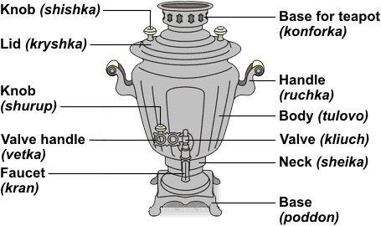

айдите соответствие английского слова и картинки.

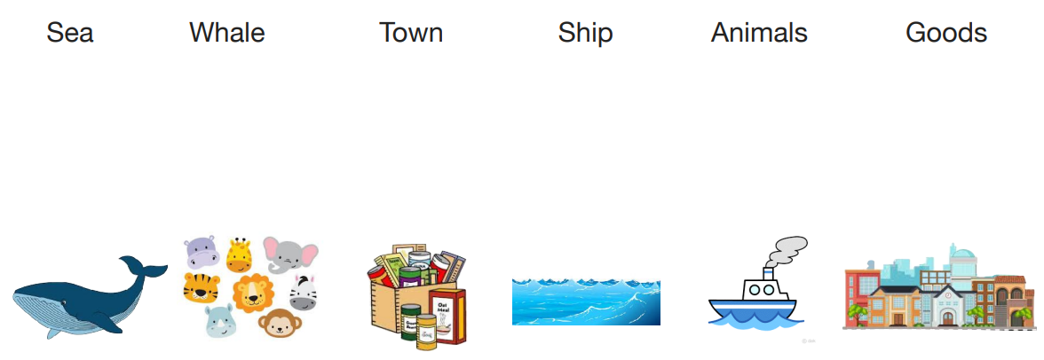

ЗАДАНИЕ 4
Выберите себе роль и прочтите сказку для других участников. Назовите свою роль, используя конструкцию I will be the …
Роли
Author
Whale
Sailors
Angel
Hero

ЗАДАНИЕ 5
USE - ИСПОЛЬЗОВАТЬ
ENJOY - НАСЛАЖДАТЬСЯ
ORNAMENT - ОРНАМЕНТ
GEOMETRIC - ГЕОМЕТРИЧЕСКИЙ
FLORAL – ЦВЕТОЧНЫЙ
COLORS – ЦВЕТА
IMAGES - ОБРАЗЫ
IRON - ЖЕЛЕЗО
GLASS - СТЕКЛО
WOOD – ДЕРЕВО
TEXTILE - ТКАНЬ
BONE – КОСТ Ь
STONE – КАМЕНЬ
CARVING - РЕЗЬБА
EMBROIDERY – ВЫШИВКА
PAINTING – ЖИВОПИСЬ
OBJECTS OF DECORATIVE ART – ПРЕДМЕТЫ ДЕКОРАТИВНОГО ИСКУССТВА
THE ALL-RUSSIAN DECORATIVE ART MUSEUM – ВСЕРОССИЙСКИЙ МУЗЕЙ ДЕКОРАТИВНОГО ИСКУССТВА

